Login to Solid Waste Database

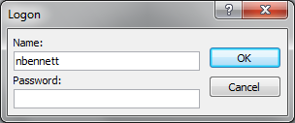

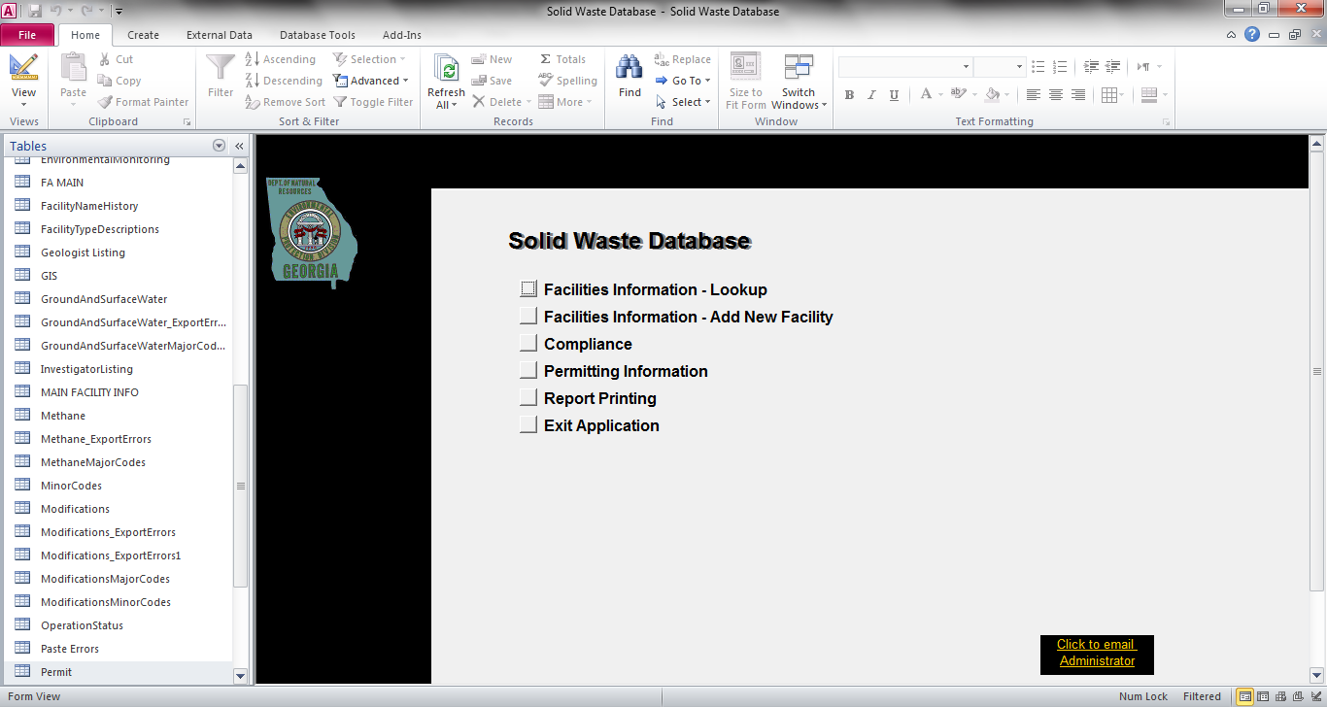

Click on Facilities Information – Lookup

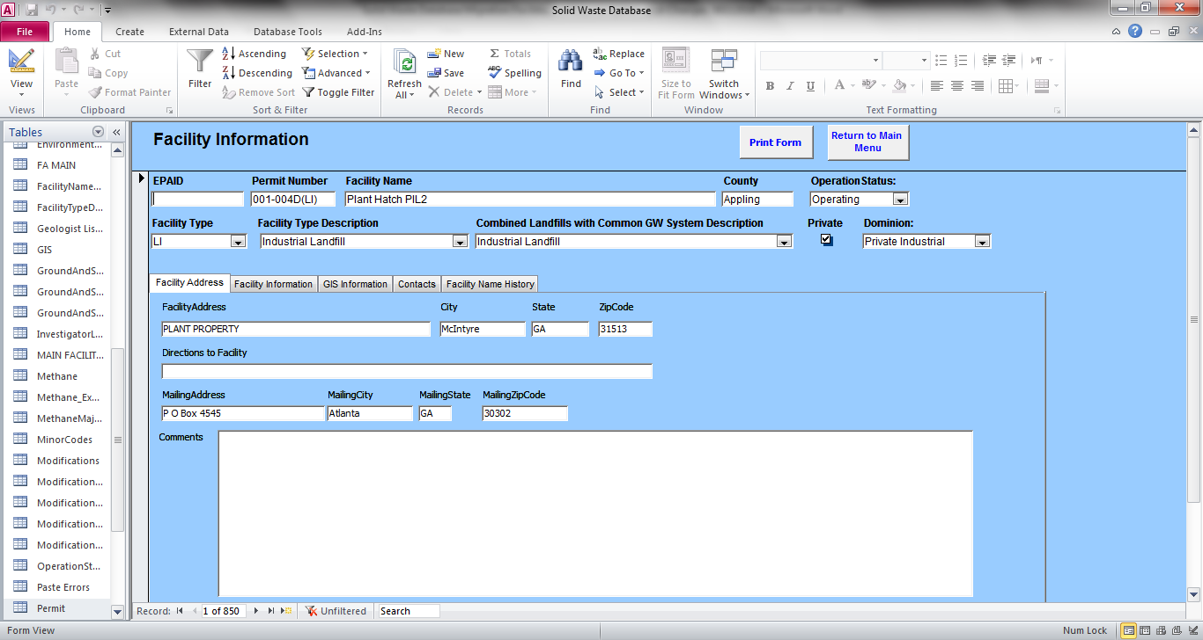

Toolbar – used for queries



1. The first field, EPAID – is a field we will migrate.

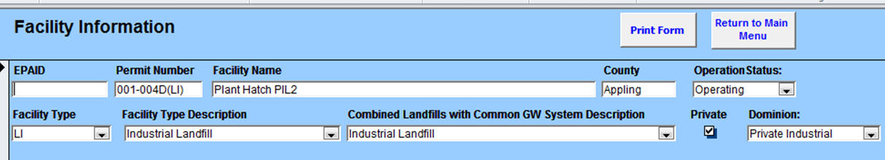

**EPAID is a field to be migrated.**

1. Permit Number, Facility Name, County and Operation Status are fields that we need to be migrated



**Important information needs to be migrated**

1. Operation Status has too many fields. Suggest narrowing fields. Each environmental interest will need it’s own Operation Status field.

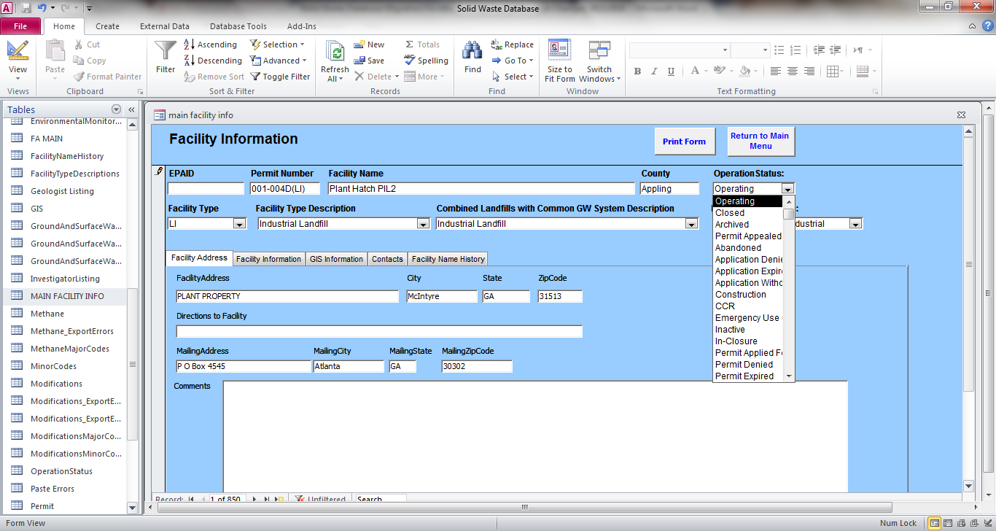

|  |  |
| --- | --- |
| Application Withdrawn | Operating |
| Archived | Permit Appealed |
| CCR | Permit Applied for |
| Closed | Permit Denied |
| Construction | Permit Expired |
| Emergency | Permit Inactive |
| Inactive | Permit revoked |
| In-Closure | Released |

**Suggest narrowing fields**

**Each Environmental Interest will need it’s own Operation Status**

1. Remove the Facility Type field.



**Remove**

1. The Facility Type Description - is a field we will migrate.



**Facility Type Description - is a field we will migrate**

|  |  |  |  |
| --- | --- | --- | --- |
| Air Curtain Destructor | Incinerator | Municipal Solid Waste LF | Shredder |
| Autoclave | Industrial | Other | Thermal Treatment |
| Baler | Industrial – Storage & Trans | Petroleum Cont Soil Proc | Tire LF |
| Biomedical Processor | Industrial – Dewatering | Private Industrial Disposal | Transfer Station |
| Collection Industrial | Industrial – incinerator | Processor | Unlined Sanitary LF |
| Composting | Industrial LF | Processor- Compostor | Waste to Energy Facility |
| Composting – MRF | Industrial – Waste Treat | Processor-RMF |  |
| Composting – Demo LF | Industrial – Water Treat | Processor – Industry |  |
| Dewatering Facility | Inert LF | Recovered Materials |  |
| Dry Trash LF | Material Recovery Fac | Sanitary LF |  |

1. Change Combined Landfill with Common GW System Description to “Shared GW System.” Three options Yes/No/unknown.

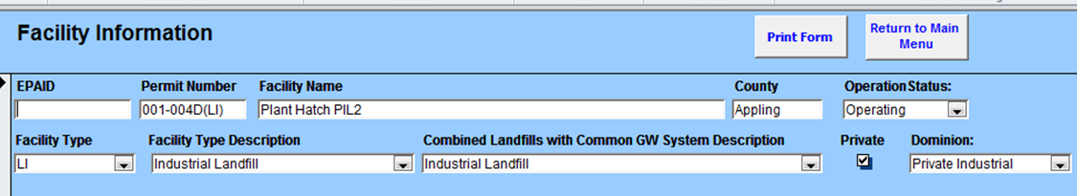

**Change the name of this field “Shared GW System” with three options for a pull down menu – Yes/No/Unknown**

1. Remove “Private” Checkbox



**REMOVE**

1. The Dominion Field is useful to Susan. The Dominion field will be retained for migration. Suggest adding a brief description of the Dominion.



**Field to be migrated – Suggest including a brief description of each Dominion**

|  |  |
| --- | --- |
| **Dominion** | **Description** |
| Private Industrial |  |
| Private Commercial |  |
| ~~Commercial Industrial~~ | Change to Private Commercial |
| Public |  |

1. Facilities Information has five tabs:

* Facility Address
* Facility Information
* GIS Information
* Contacts
* Facility Name History

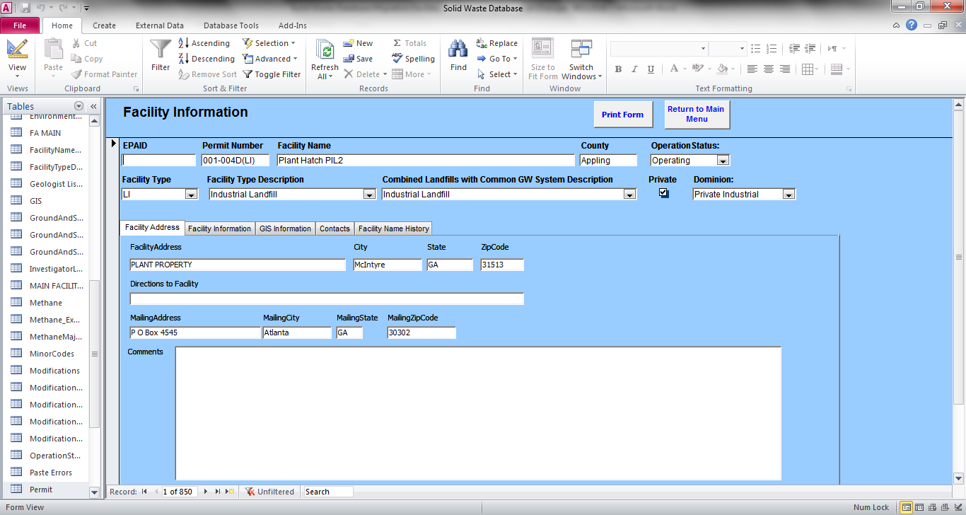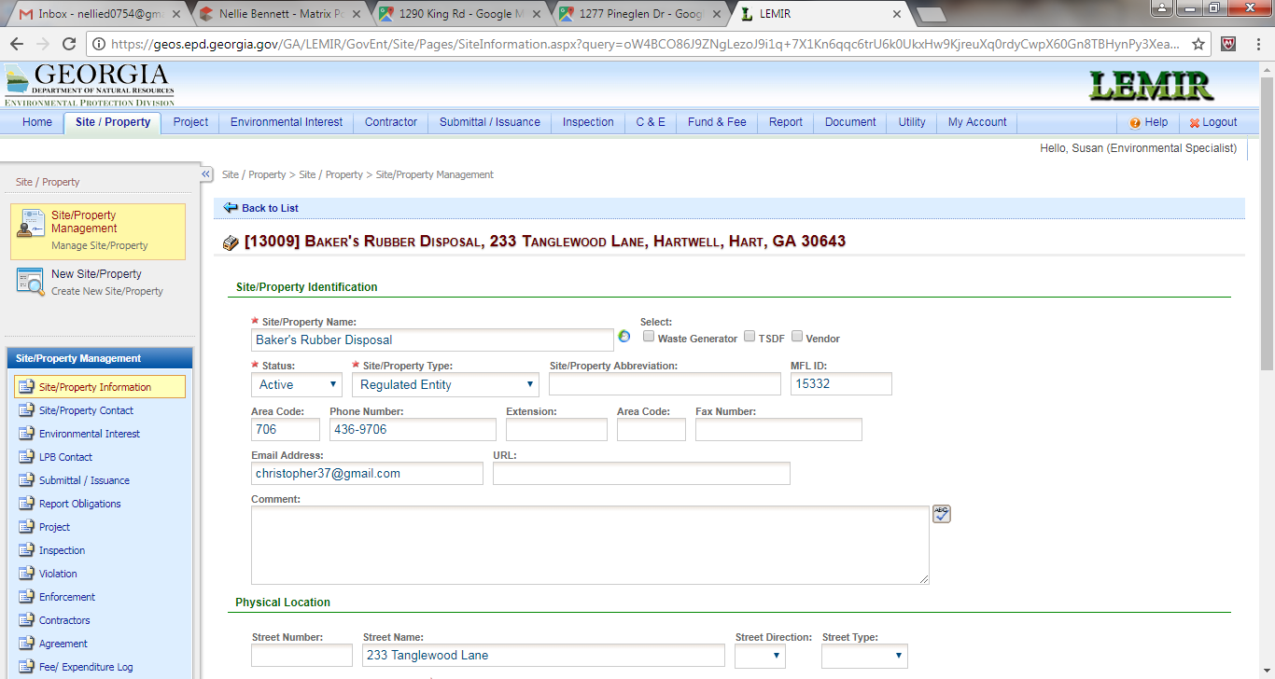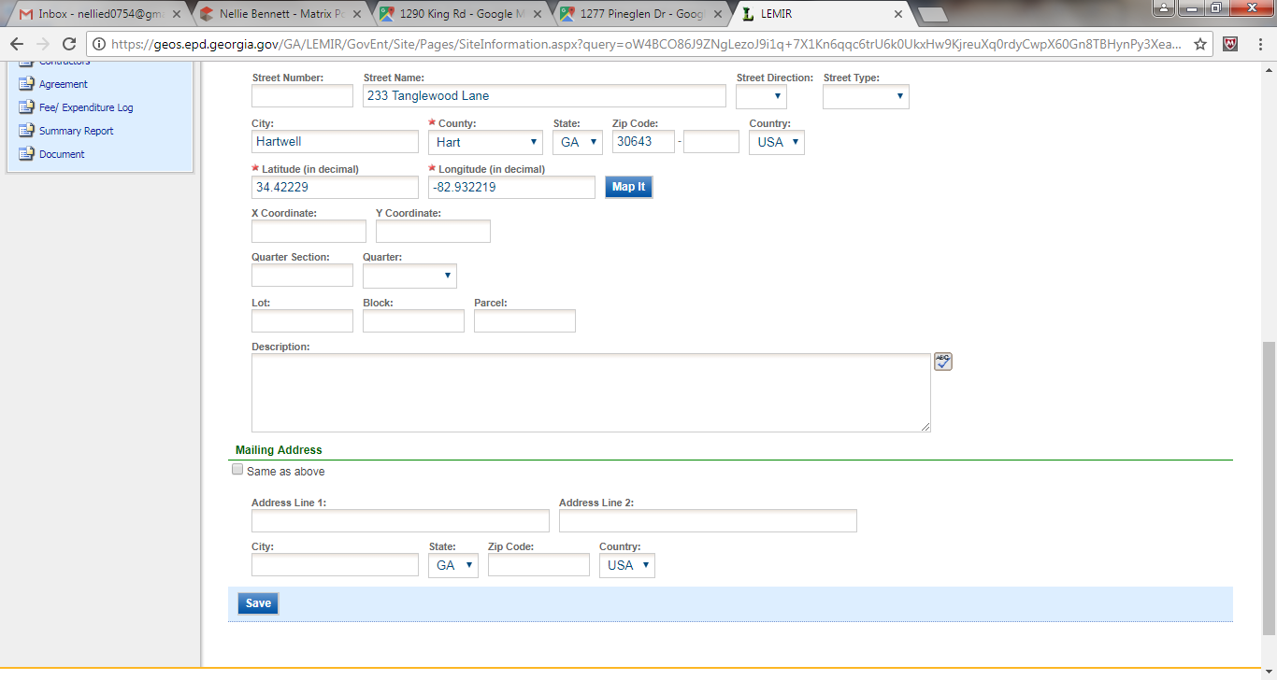

The Tab for Facility Address and Facility Name, Facility Name History could be included in Site Property information (Opening Page), as it is in Scrap Tire.

**Facility Info, GIS Info and Contacts can be found here**

Facility Information – Facility Address Tab

1. Facility Address, City, State, Zip Code - are important fields and need to be migrated



**Important information needs to be migrated**

1. Remove - Directions to Facility field



**Remove**

1. Mailing Address, Mailing City, Mailing State, Mailing Zip Code and Comments – are all important fields to be migrated.



**Important information needs to be migrated**

1. The fields in Facility Address. We want searchable, as it is in Scrap Tire.

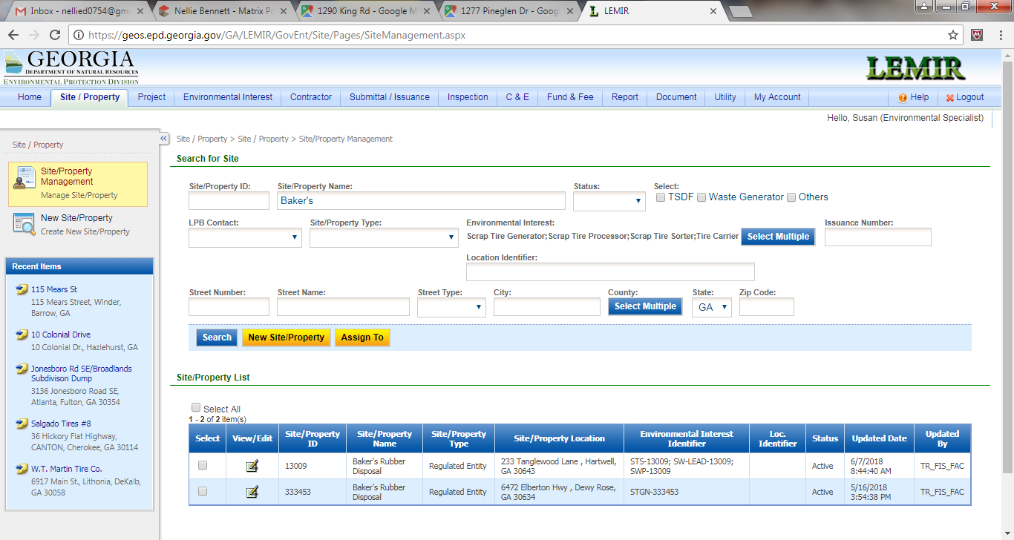

Facility Information – Facility Information Tab

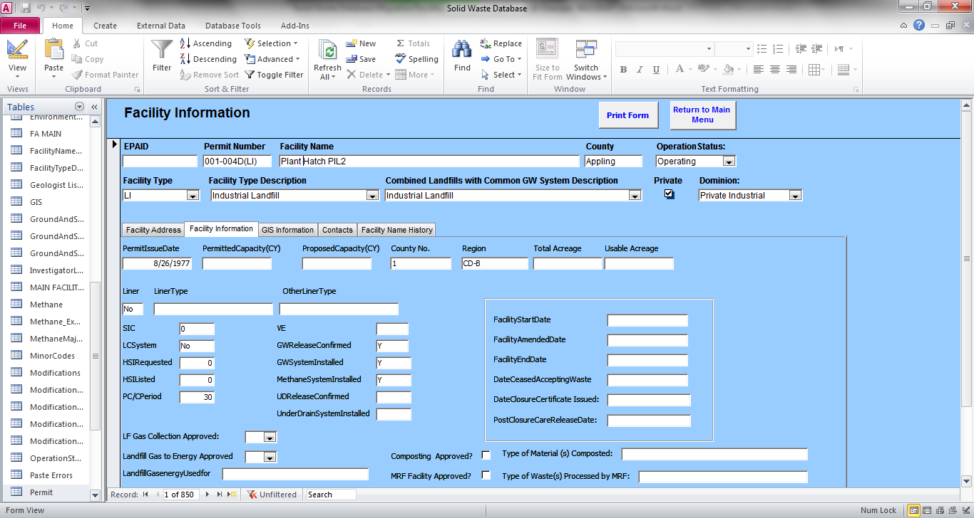

1. The Permit Issue date and Permitted Capacity are important and need to be migrated. Proposed Capacity should be included in applications only and transfer to Permitted Capacity upon issuance of a Permit or approval of a major modification.

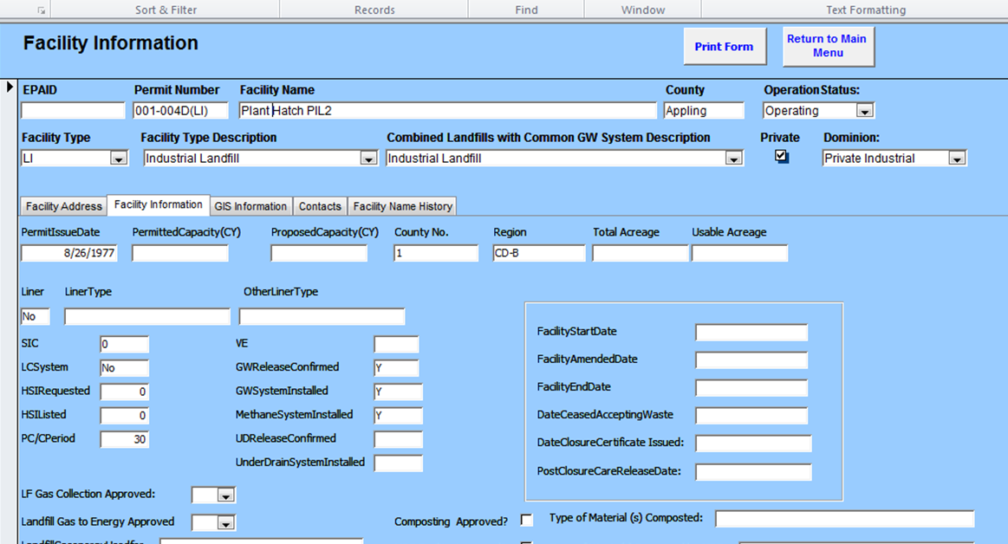

**Important information needs to be migrated**

Proposed Capacity should be included in applications only and transfer to Permitted Capacity upon issuance of a Permit or approval of a major modification.

1. County No. is redundant and can be eliminated.



**REMOVE**

1. Region is useful information. Rename the field “District Office”. Instead of acronym - the full name of the district.



**Rename the field “District Office”. Instead of acronym - the full name of the district.**

**We would like this field to be a drop down menu with the full name of the district (table below)**

|  |  |
| --- | --- |
| CD-B | Coastal District - Brunswick |
| MD | Mountain District - Cartersville |
| MD-A | Mountain District – Atlanta |
| NE-ATH | Northeast District – Athens |
| NE-AUG | East Central District - Augusta |
| SW | Southwest District - Albanty |
| WC | West Central District - Macon |

1. Total Acreage and Usable Acreage are useful fields and needs to be kept.

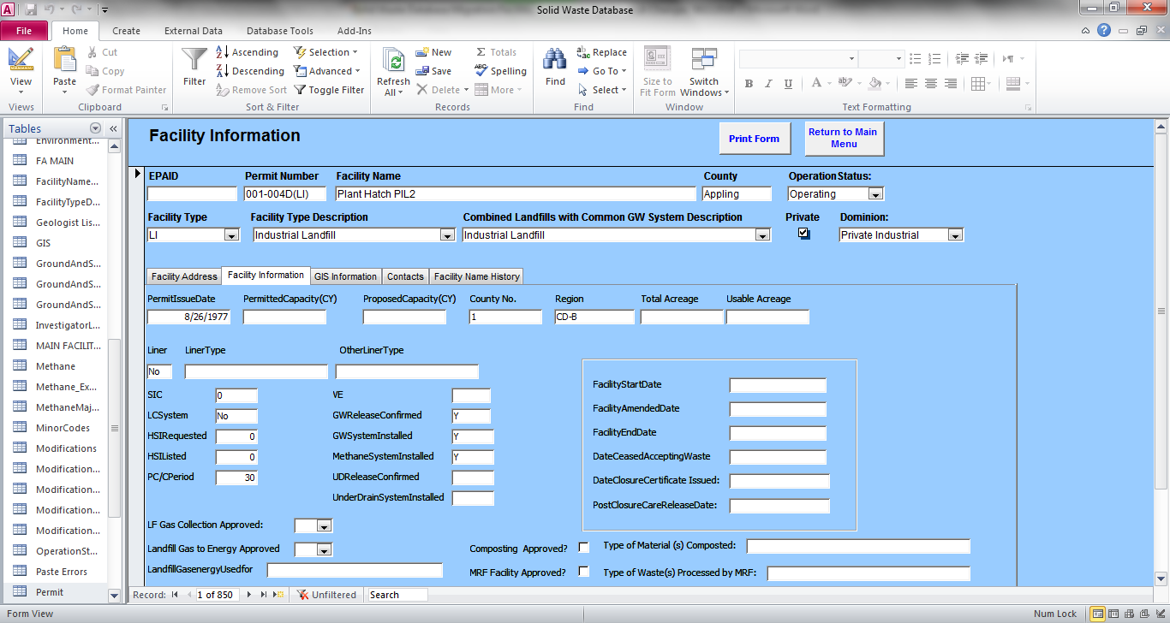

**Important information needs to be migrated**

1. Liner – Three options for the liner field (Yes, No, Partial)



**Liner field (Yes, No, Partial)**

**Drop down menu Yes, No, Partial**

1. Remove Liner Type and Other Liner Type



Remove

1. Remove SIC, LC System, HSI Requested, HSI Listed



**Remove**

1. PC/CPeriod – Renamed “Post Closure Care Period” – field to be migrated.

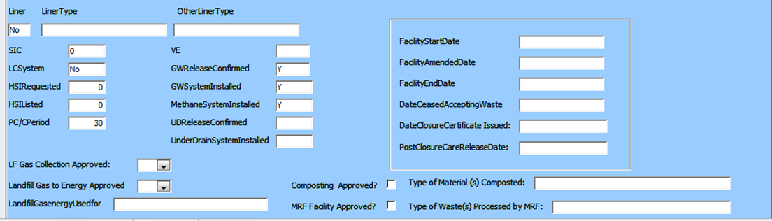

**PC/CPeriod - to be migrated**

**Change the name of this field to “Post Closure Care Period”**

1. Remove VE, GW Release Confirmed, UD Release Confirmed



**KEEP**

**KEEP**

**Remove VE, GWRelease, UD Release**

1. GW System Installed, Methane System Installed, Under Drain System Installed are important for Environmental Monitoring and need to be migrated



**Important information needs to be migrated**

1. Include a new Field – “Date of Application”. Located Before Facility Start Date (newly labelled “Date Facility Started Receiving Waste”)

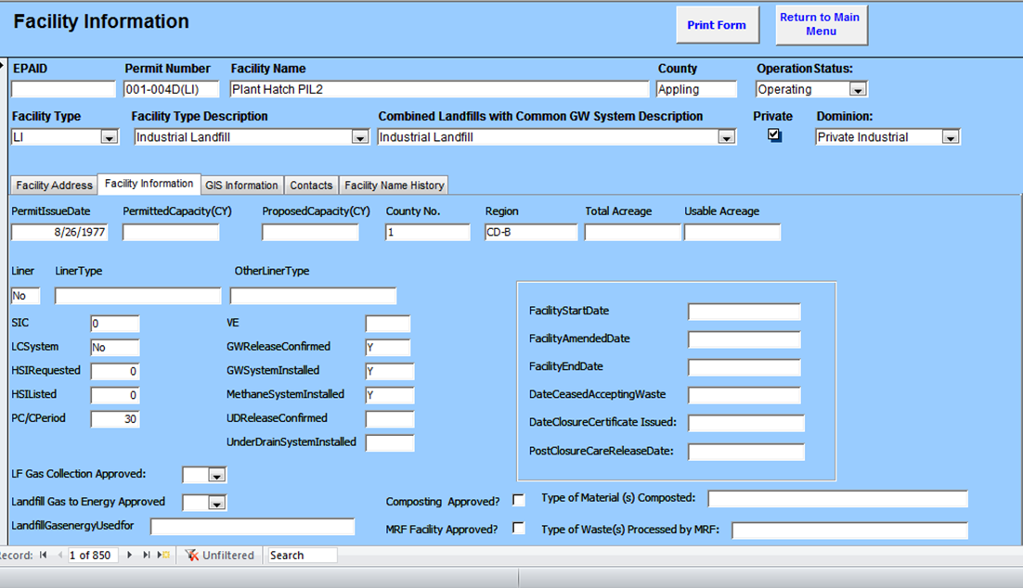

**Date of Application**

**New Field!!!**

1. Facility Start Date is an important field that needs to be migrated – Change the name of the field to “Date Facility Started Receiving Waste”



**This is an important field to be migrated -**Change name to “Date Facility Started Receiving Waste”\*\***

1. Remove Facility Amend Date and Facility End Date



**Remove Fields**

1. Date Cease Accepting Waste, Date Closure Certification Issued, Post Closure Care Release Date are all important fields to be migrated.



**These are important fields to be migrated**

1. LF Gas Collection Approved field is important for Environmental Monitoring and needs to be migrated



**LF Gas Collection Approved needs to be migrated**

1. Remove Landfill Gas to Energy Approved and Landfill Gas Energy Used for Fields.

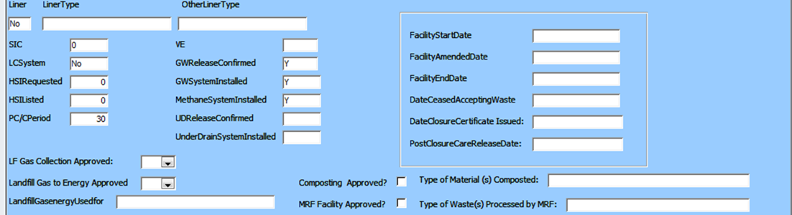

**Remove**

1. Remove - Composting Approved, Types of Material Composted, MRF Facility, Types of Waste Processed by MRF, CD Landfill, CD Landfill Operation Status, Inert Landfill, Inert Landfill Operation Status, Transfer Station, Transfer Station Operation Status. We hope for these fields to be reflected in the Site Specific Environmental Interests

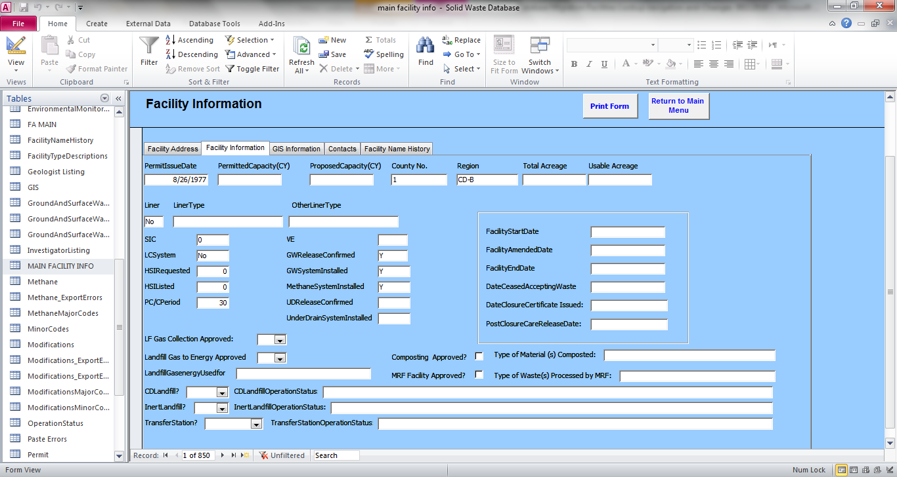

**Remove these Fields**

NEXT TAB

Facility Information -GIS Information

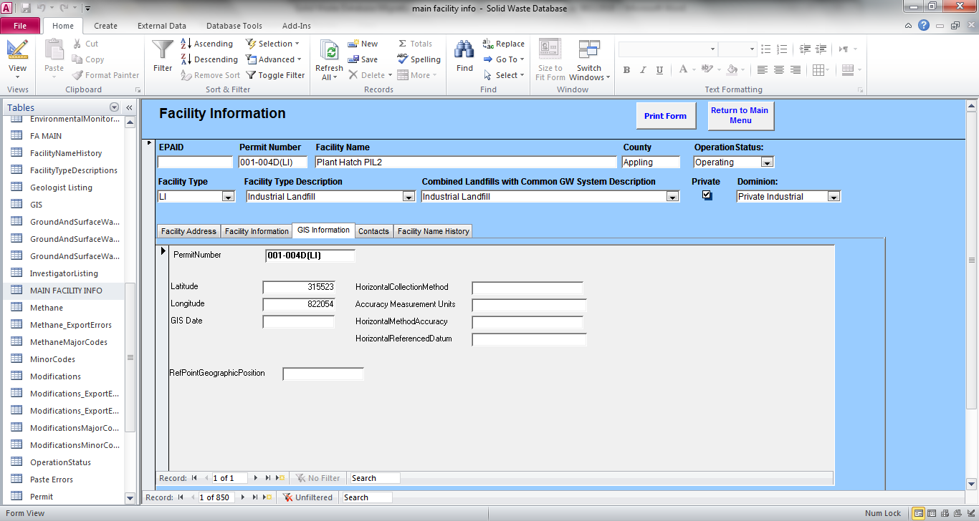

1. Latitude and Longitude are important fields that need to be migrated



**These two fields are important and need to be migrated**

1. Remove GIS Date, Horizontal Collection Method, Accuracy Measurement Units, Horizontal Method Accuracy, Horizontal Referenced Datum, Rel Point Geographic Position (Do we keep this?)

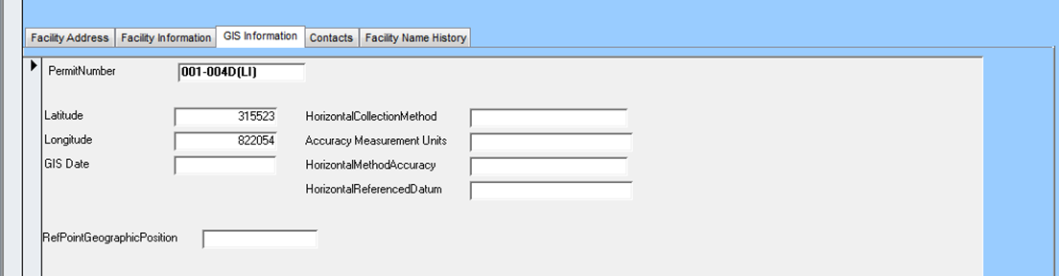

NEXT TAB

Facility Information - Contacts

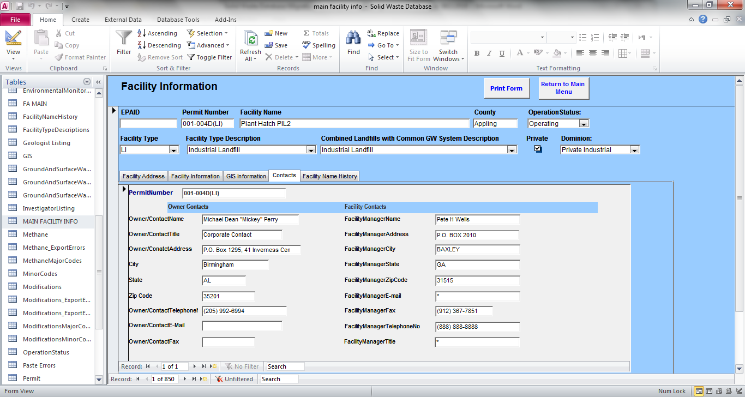

1. Change Owner/Contact Name to “Contact Name”, Owner/Contact Title to “Contact Title”, Owner/Contact Address to “Contact Address” - All of these fields are to be migrated

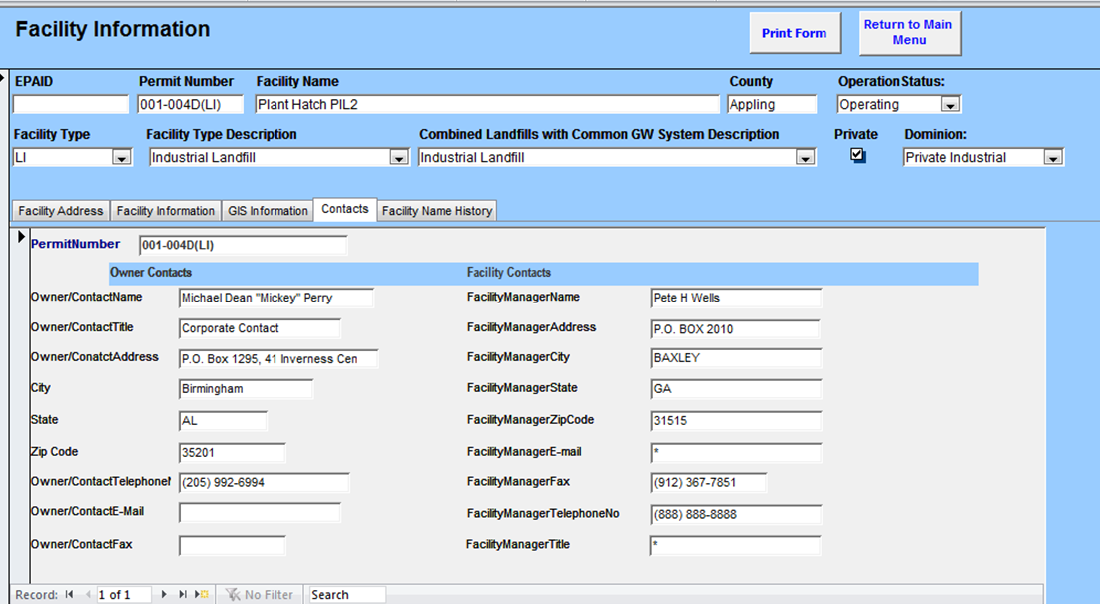

**Change Owner/Contact Name to “Contact Name”, Owner/Contact Title to “Contact Title”, Owner/Contact Address to “Contact Address”**

**All fields – to be migrated**

1. New Field! – Entity/Owner Name, Address, Phone, email etc.
2. All Facility Contact fields are to be migrated.

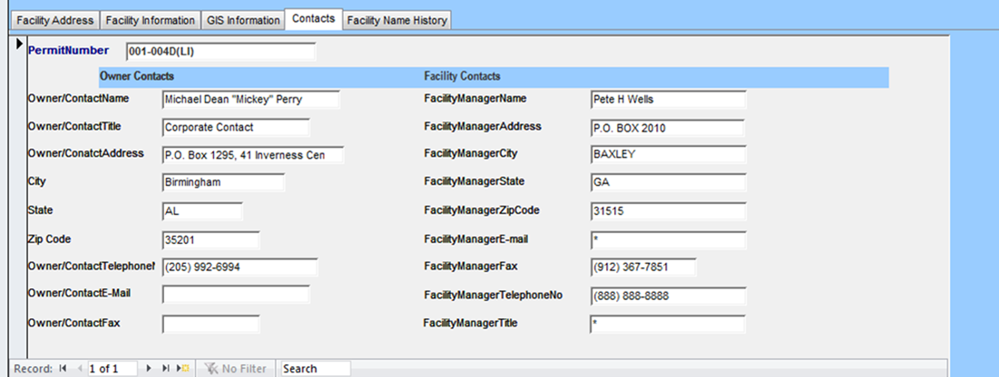

**New Fields – Entity/Owner Name, Address, Phone, etc.**

**All fields – to be migrated**

NEW TAB

Facility Information – Facility Name History

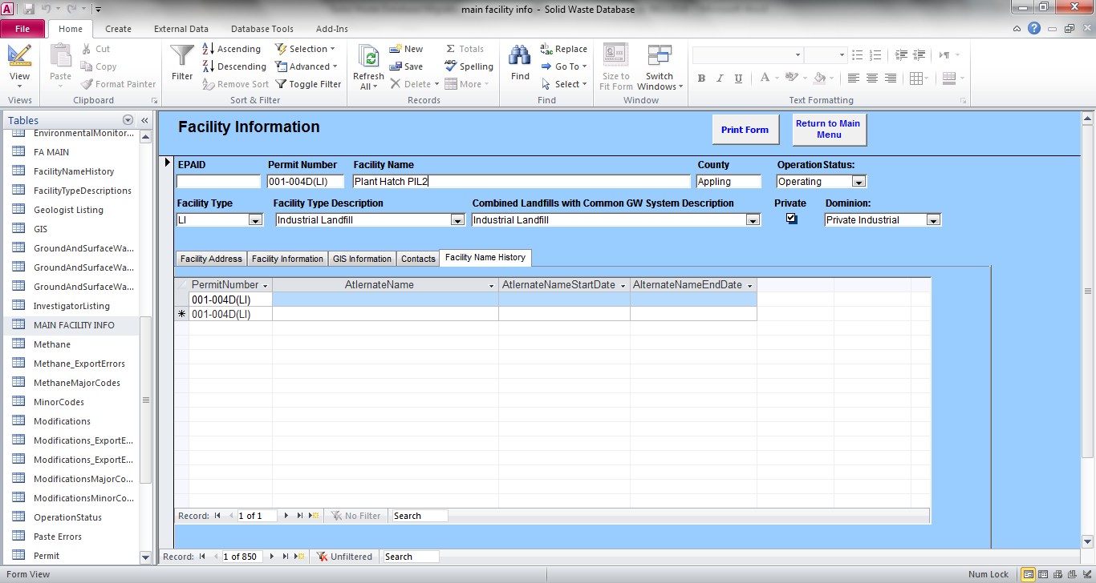

1. This information is important and needs to be migrated. The hope is to have this information captured in a button that you can click on “show change history”

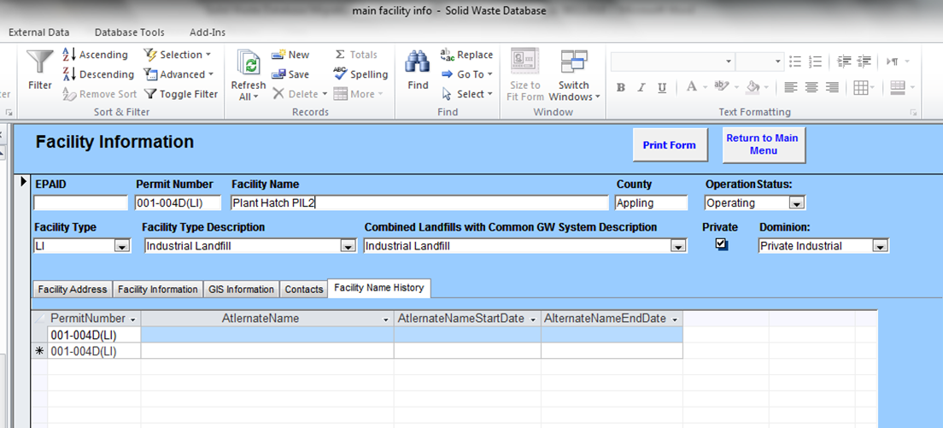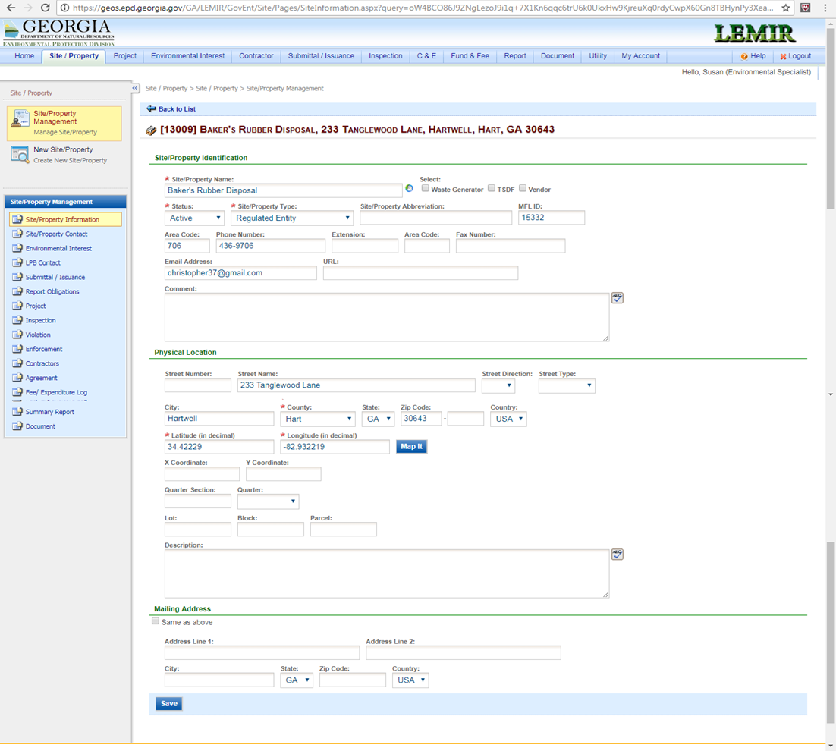

**This information will be captured in a button of some type, “show change history”**

When you search for Site/Property Name “Baker’s Rubber” you have these two options here. The top option you can see the multiple environmental Interest Identifiers. Here will list the other types of permits associated with that landfill, in our case. It would be great if these permits in this field were links, where you could click and bring up that specific permit.

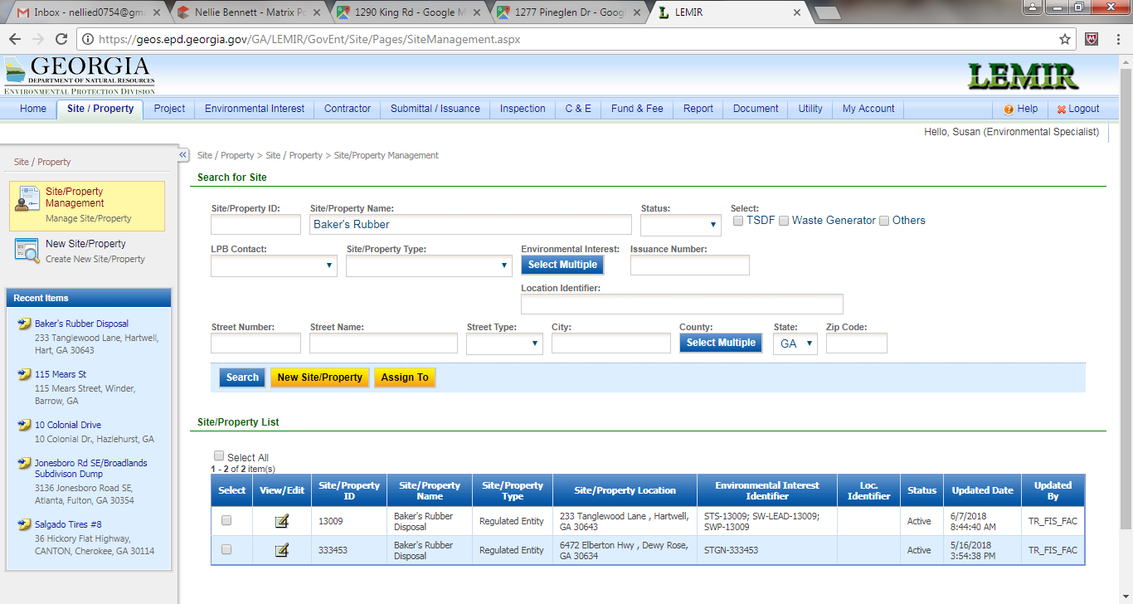

**Every permit associated with this landfill located here. Could we get a link where you can click to see that particular associated permit’s file.**

Click on the first Baker’s Rubber Disposal. The window below opens. Then click on Environmental Interests.

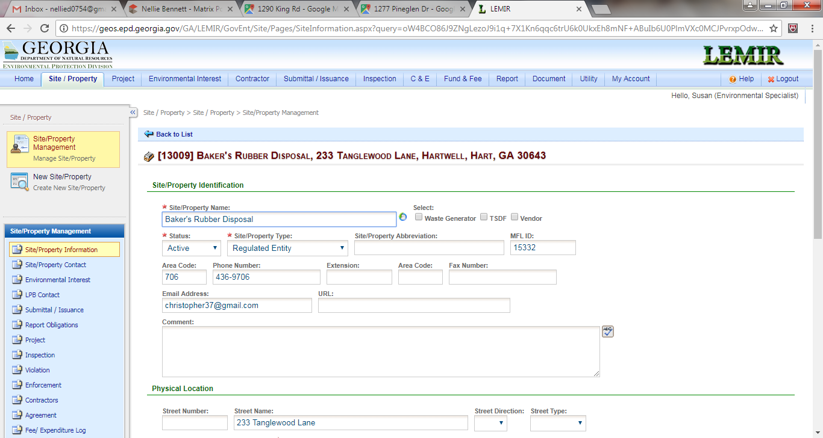

Here would be the other associated permit’s. We’d have to determine what we’d want to be able to see here. Again, it would be nice if we could have a link where we click on the permit number and it opens up that permit’s site/property window. Produce a list of associated Permit types.

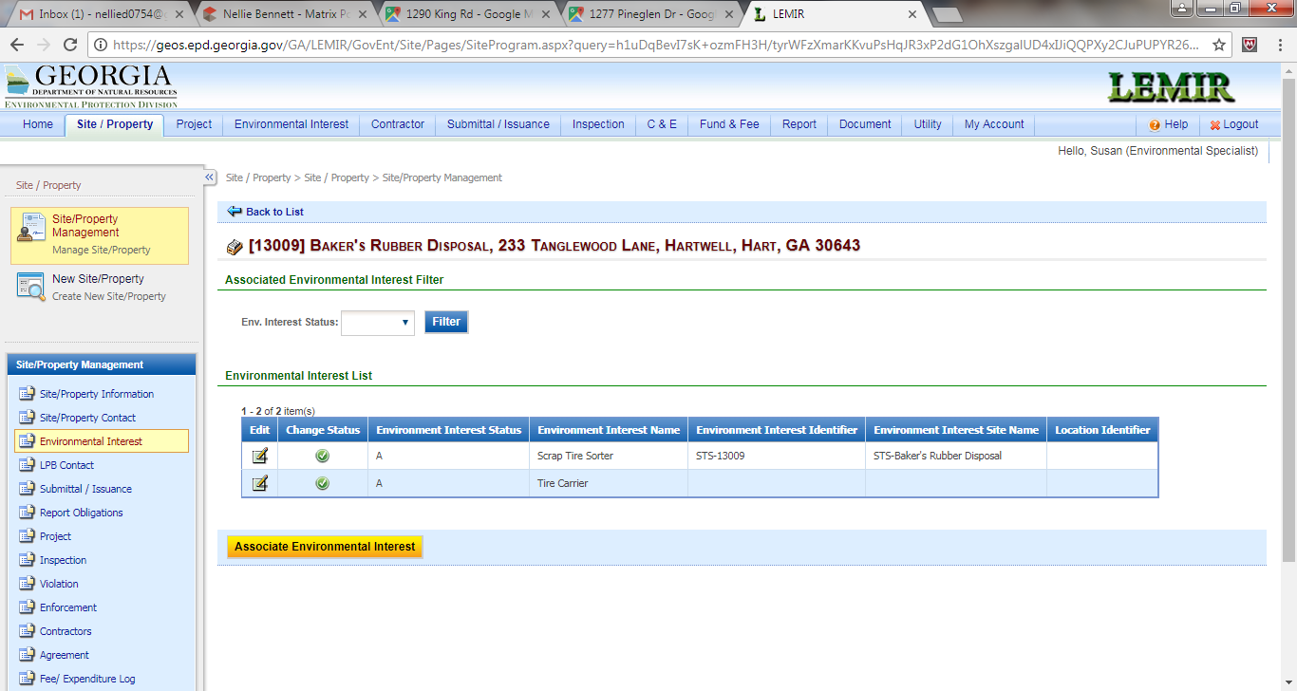

This would be the type of Environmental Interest MSW, C&D, PBR, etc.